8-Unit Complex (4 Duplexes) in Quiet Downtown Neighborhood

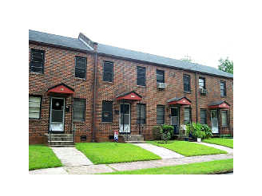 | Primary Type: Multi-Family Residential  Garden-Style Low-Rise  No. of Units: 8  Price: $400,000  Cap Rate: 9%  Year Built: 1950  Lot Size: .44 Acres

Property Description:
Eight unit, all-brick complex in downtown Maybury neighborhood. Mix of units with two-story townhome floor plans, front and back entrances and hardwood floors. The property currently has 7 residents and one vacancy. The 8th unit has some damage and would require about $10,000 in repairs before leasing.

Financial Summary Pro-Forma | Unit Mix
Year 2007  Gross Income $54000  Other Income (Laundry) $2400  Vacancy 12%  Expenses  Taxes $4000  Insurance $600  Maintenance $3000  Advertising $300  Utilities $2000  Net Operating Income $37169 | Unit Mix / Rent  4 1BR+1BT / $525  2 1BR+1BT / $550  2 2BR+1BT / $650

